**How Does the Covid-19 Affects the Economy in the Philippines?**

Joana Rose N. Borja

**Brief Introduction**

The Philippines are affected by the Covid-19 pandemic and many of us is also affected. Many of us need to stop in our work and many businesses and establishment need to close. Our daily routine and our lives are change by this pandemic and we never get prepared for this. Also, the National Government is not prepared for this situation, but they do their best to help the people who lost their jobs and seeking for help and food to eat. The National Government uses all of their resources and release funds for food packs and cash assistance. They give it to Local Governments to distribute to each family who in need. Every week the LGU's go around on their jurisdictions to check the status on their place. The National Government also releases an order to the electric and water companies to hold on their billings and collections to help the jobless people due to pandemic and make an arrangement on their monthly dues thru installment basis.

**Your Goal**

Because of covid-19 many of us is in hard time recovering the damage of the pandemic specially in business and employment. The main goal here is the government should pass a law if we hit again of pandemic. They should build an accurate guidelines and protocols to protect the economy and the people of the country. They should allocate a separate fund or savings, when the time that a pandemic comes again. By passing a law the business, people and the economy are secure that we don't experience again the worse caused by a pandemic or even a large disaster.

I

Top of Form

**Table of Contents**

Title ---------------------------------------------------------------------------------------------- I

Brief Introduction ------------------------------------------------------------------------------- I

Your Goal ---------------------------------------------------------------------------------------- I

Dataset Description ----------------------------------------------------------------------------- III

Output [Screenshots] --------------------------------------------------------------------------- IV

Conclusion --------------------------------------------------------------------------------------- V

Citation/Sources -------------------------------------------------------------------------------- VI

II

**Dataset Description**

|  | **IMPACT OF COVID-19 ON KEY PHILIPPINE ECONOMIC SECTORS** | **Share of 2019 Gross Value added (in billion pesos)** | **Worse Case** | **Moderate Case** | **Best Case** |
| --- | --- | --- | --- | --- | --- |
| **0** | 1 | Manufacturing | 855.2 | 421.8 | 82.1 |
| **1** | 2 | Wholesale and Retail Trade | 724.8 | 497.7 | 93.2 |
| **2** | 3 | Other Services | 356.9 | 221.0 | 41.5 |
| **3** | 4 | Financial Intermediation | 141.3 | 98.9 | 18.5 |
| **4** | 5 | Transportation, Storage and Communication | 124.3 | 61.6 | 11.7 |
| **5** | 6 | Agriculture, Forestry and Fishing | 110.3 | 50.5 | 9.4 |
| **6** | 7 | Real Estate, Renting and Business Activities | 79.7 | 56.8 | 10.7 |
| **7** | 8 | Electricity, Gas and Water | 44.3 | 30.5 | 5.7 |
| **8** | 9 | Mining and Quarrying | 26.9 | 8.7 | 5.2 |
| **9** | 10 | Construction | 20.4 | 10.0 | 4.1 |

III

This dataset only shows how the economy drops and collapse caused by the covid-19 pandemic. One of the reasons for this was the unexpected lockdown thar occurred across the country causing the closing of many business and establishments. Many businesses and entrepreneurs experience huge loss of income that caused of reduction of employee. If you noticed, the worst case since we have this pandemic is the loss of income of the businesses. And some of them need to be closed permanently.

Output [Screenshots]

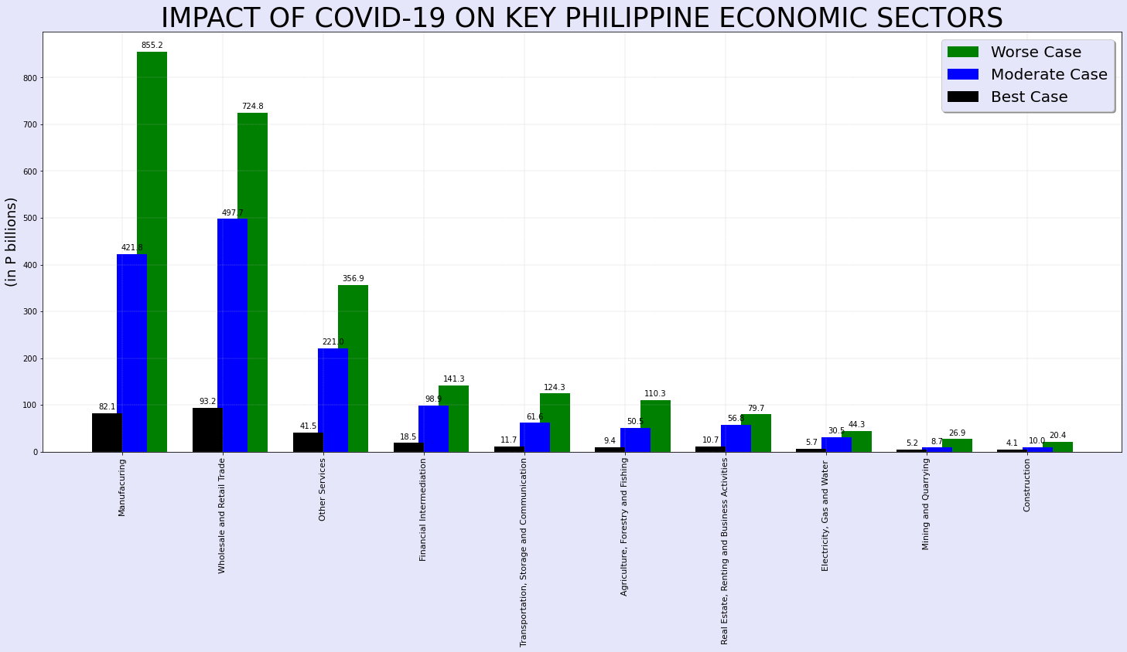

IV

**Conclusion**

Based on my findings because of the covid-19 pandemic, we experience big changes in our lives. At this time, we all experience on what we call The New Normal. We need to follow all new rules and guidelines like always wearing a face mask and face shield every time we go out; we need to follow the social distancing and lockdown on the affected area or infected area. We need to minimize our leisure just to prevent on getting infected by the virus. Many of us are afraid to get infected by the virus but we need to fight and strong for our self and family. We need to find ways to support our daily needs. Our country also faces many problems one of these are the natural calamity like storms which is normal in the country specially in rainy season. Flash floods is the one of the problems in low lying areas and storm surge in coastal areas. Evacuation is one of the big challenges for the authorities. Because of the pandemic, the authorities need to implement the social distancing on evacuation centers and keep the center always clean. We all now live in a very different environment, we need to keep our self-clean, always wash our hands and sanitize to keep away from the deadly virus. We cannot go out and have fun or even visit our love ones. All of us are hoping and praying that the medicine or vaccine for this virus are soon to made and available. But for now, we need to follow all the protocols and always keep safe.

V

**Citation/Sources**

[https://l.facebook.com/l.php?u=https%3A%2F%2Fwww.eccp.com%2Farticles%2F%3Fid%3D2218%26fbclid%3DIwAR3TQ-QQ7CjzB37n-TVCHH7P5UUlTEEKIzlUY6_rlZrVqBQC7bbqmfAwKCY&h=AT3lbmnqOc25fuDGf-Jiqsbx3jXPpl0RMMi7Jn2WWb6sSTEreH1RgfoZ5LrctFFzIH6b_eNGzK4Tas7t971ZzxOwyL-Jx6ZgazE_xPrMewYmueeWIHaJgkLiUmfdRymTpjCa5A](https://l.facebook.com/l.php?u=https%3A%2F%2Fwww.eccp.com%2Farticles%2F%3Fid%3D2218%26fbclid%3DIwAR3TQ-QQ7CjzB37n-TVCHH7P5UUlTEEKIzlUY6_rlZrVqBQC7bbqmfAwKCY&h=AT3lbmnqOc25fuDGf-JIqsbx3jXPpl0RMMi7jN2WWb6sSTEreH1RgfoZ5LRctFFzIH6b_eNGzK4Tas7t971ZzxOwyL-Jx6ZgazE_xPrMewYmueeWIHaJgkLiUmfdRymTpjCa5A)

By **C.A.V. Olano**

Source: [Business World Online](https://www.bworldonline.com/coronavirus-may-cost-phl-up-to-p2-5-trillion-in-economic-output/)

VI